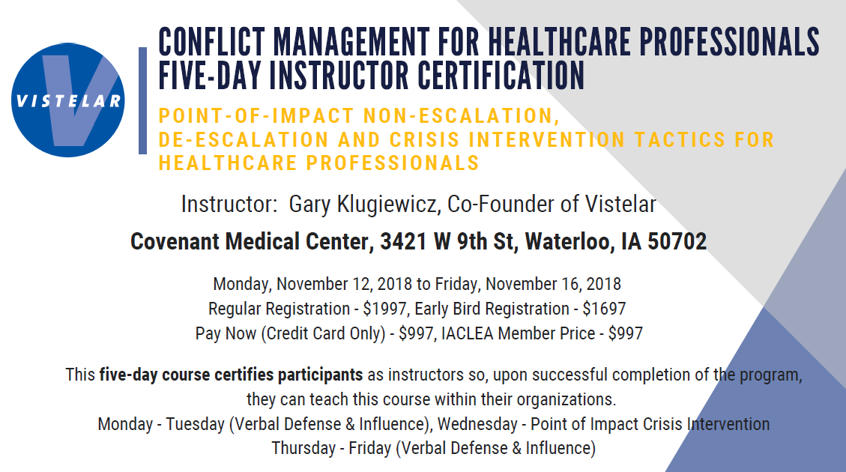
Audience: RN, LPN and Allied Health Professionals
Objectives:
- Identify methods to reduce conflict or unnecessary escalation of situations
- Review the 6 C's of Conflict Management
- Define and demonstrate the persuasion sequence in verbal de-escalation
- Manage verbal abuse in a confident and professional manner
- Engage in difficult conversations and mediate positive outcomes
- Define and demonstrate how to de-escalate conflict effectively
- Maintain personal and patient safety during crisis situations
- Recognize action steps when word-based tactics fail to resolve conflict

Nursing Continuing Education: 33.0 Nursing Contact Hours provided by Iowa Board of Nursing Provider #128
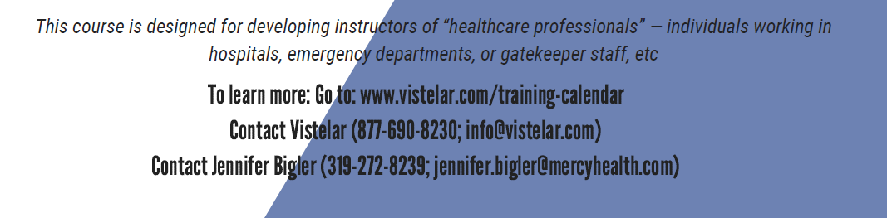
Held in Meeting Room 13 each day
0800-1430
(Lunch on your own)

