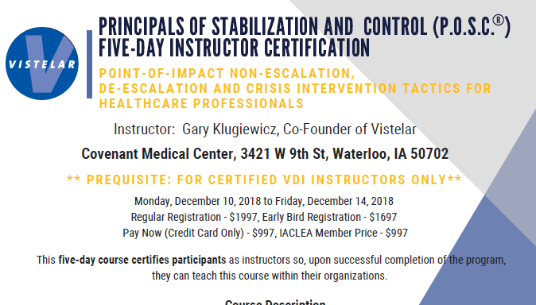
Audience: RN, LPN, and Allied Health Professionals
Objectives:
- Apply the first responder philosophy in relation to crisis situations
- Demonstrate proxemics for exit, evade, and escape strategies
- Demonstrate physical interventions including prohibited holds
- Demonstrate six levels of stabilization in crisis intervention
- Demonstrate Supine and Transitional Prone stabilization
- Demonstrate stabilization including ground, standing, and sitting
- Discuss airway maintenance during stabilization techniques
- Discuss crisis intervention and medically significant behavior common in behavioral health populations
- Review concepts of trauma informed care
- Apply personal safety tactics when interacting with a violent patient
- Discuss caregiver misconduct
- Respond to self-harming patients in both small and large room scenarios
- Describe Half Down decentralization tactics
Held in Meeting Room 13 each day
0800-1430
(Lunch on your own)
- Discuss pre-incident responses and spontaneous incident responses
- Identify strategies to overcome fight or flight response
- Demonstrate universal greeting
- Discuss ethical considerations in crisis intervention
- Perform drills and safety protocols for stabilization
- Discuss injury and liability management

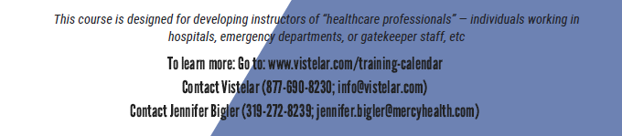
Continuing Education: 33.0 Nursing Contact Hours by Iowa Board of Nursing Provider #128

